Shrinkage correlation: GBPUSD and USDCHF
Method 08 / eight-major panel / delta = 0.2 and Ledoit-Wolf / Alpari D1 full available history

Study setup
Logical pair: GBPUSD , USDCHF
Broker symbols: GBPUSD_i , USDCHF_i
Snapshot: 2026-11-03_majors_alpari_D1
Timeframe: D1
Common eight-major panel window: 1999-01-06 to 2026-11-02 (UTC bar dates)
Panel matched return count n: 7127
Dropped unfinished last bar dated 2026-11-03 UTC after a tick-volume check against the prior complete day.
Fixed shrinkage: delta=0.2, mu=3.9170889e-05 (mean of diag(S))
Ledoit-Wolf estimated delta: 0.0042157642
Panel symbols: EURUSD, GBPUSD, AUDUSD, NZDUSD, USDJPY, USDCHF, USDCAD, EURGBP
Complete matched rows (Excel): GBPUSD-USDCHF_Shrinkage_D1.xlsx
Complete matched rows (HTML table): GBPUSD-USDCHF_Shrinkage_D1_data.html

Method carried forward
Shrinkage blends the sample covariance matrix S of matched daily log returns of close, ln(close_t / close_t-1), toward a simple target, then converts the shrunk covariance into correlations. Quotes are not inverted. This experiment builds one common calendar across all eight majors, forms S with the unbiased n-1 divisor, then reports two shrinkage specs: fixed delta = 0.2 with mu equal to the average sample variance (mu * I target), and sklearn Ledoit-Wolf with its estimated delta. Pair reports pull rho_ij from those panel matrices. Same-panel Pearson r is a side check only. Shrinkage improves conditioning; it is not a cause, not a lead, and not a trading signal.

Results
pearson_r | rho_02 | rho_LW | rho_02_minus_r | rho_LW_minus_r | delta_LW
-0.484413 | -0.382756 | -0.482238 | 0.101656 | 0.002174 | 0.00421576

Conclusion
Over the common 7127-day eight-major panel for GBPUSD and USDCHF (broker quote directions unchanged), fixed-delta shrinkage correlation at delta=0.2 is -0.3828 (negative, weak linear link in this sample). Ledoit-Wolf rho is -0.4822 with estimated delta=0.004216. Same-panel Pearson r is -0.4844 (rho_02 minus r = 0.1017; rho_LW minus r = 0.0022). This does not establish cause, lead-lag, or a lasting trading rule.

Charts
Daily closes
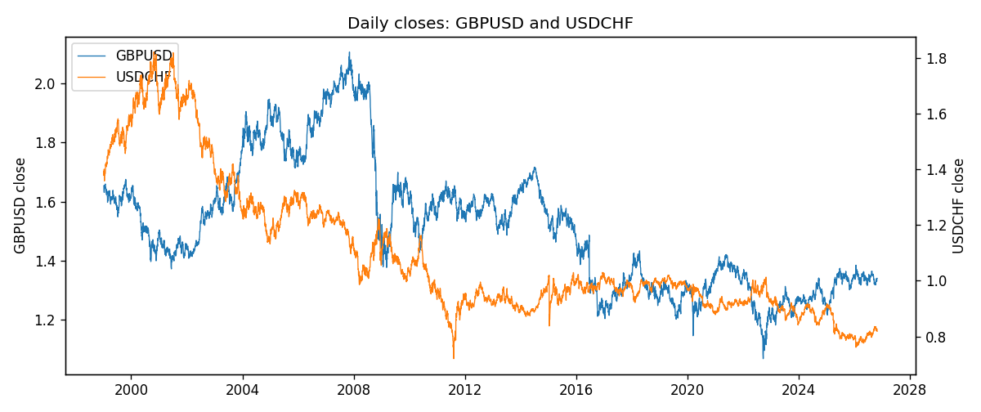
Daily log returns
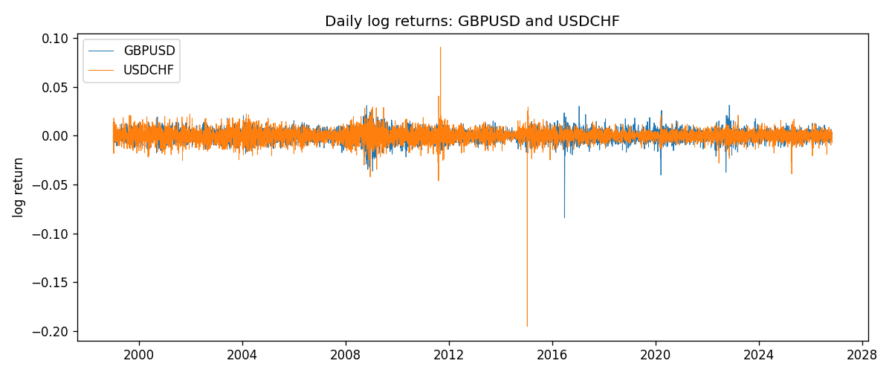
Log-return scatter
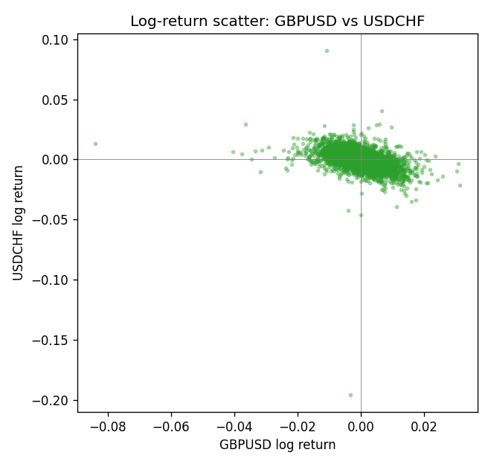

Data report
Every panel row for this pair slice is stored in the sibling Excel workbook named GBPUSD-USDCHF_Shrinkage_D1.xlsx. Full-panel covariance and correlation matrices are saved once under outputs/ as CSV files. Embedding all rows as a Word table is impractical at this length; the Word file holds the column list, column summaries, and the first and last 15 matched rows.
Columns: time, GBPUSD_open, GBPUSD_high, GBPUSD_low, GBPUSD_close, GBPUSD_tick_volume, GBPUSD_spread, GBPUSD_real_volume, GBPUSD_log_return, USDCHF_open, USDCHF_high, USDCHF_low, USDCHF_close, USDCHF_tick_volume, USDCHF_spread, USDCHF_real_volume, USDCHF_log_return
Column summaries (panel rows)
column | count | mean | std | min | 25% | 50% | 75% | max
GBPUSD_open | 7127 | 1.5143204 | 0.21800183 | 1.06854 | 1.323655 | 1.5093 | 1.62967 | 2.1066
GBPUSD_high | 7127 | 1.5206136 | 0.21856742 | 1.08366 | 1.32882 | 1.5159 | 1.636975 | 2.1161
GBPUSD_low | 7127 | 1.508003 | 0.21722806 | 1.03518 | 1.3185 | 1.501 | 1.623 | 2.0983
GBPUSD_close | 7127 | 1.5143843 | 0.21795834 | 1.06879 | 1.32373 | 1.5095 | 1.62965 | 2.1065
GBPUSD_tick_volume | 7127 | 95725.777 | 154086.85 | 62 | 10131.5 | 53562 | 92170 | 1273370
GBPUSD_spread | 7127 | 26.790936 | 19.185969 | 0 | 10 | 20 | 50 | 50
GBPUSD_real_volume | 7127 | 3.5930129e+09 | 8.4874724e+10 | 0 | 0 | 0 | 0 | 2.4038164e+12
GBPUSD_log_return | 7127 | -2.548e-05 | 0.00564718 | -0.08388241 | -0.00312586 | 3.034e-05 | 0.00318105 | 0.03112653
USDCHF_open | 7127 | 1.0950724 | 0.25120393 | 0.72022 | 0.92018 | 0.98921 | 1.23375 | 1.8219
USDCHF_high | 7127 | 1.1003422 | 0.25292835 | 0.73305 | 0.924355 | 0.99265 | 1.2388 | 1.8313
USDCHF_low | 7127 | 1.0899719 | 0.24962782 | 0.08565 | 0.91675 | 0.98562 | 1.22815 | 1.8121
USDCHF_close | 7127 | 1.0950652 | 0.25109829 | 0.72025 | 0.92039 | 0.98915 | 1.23375 | 1.8217
USDCHF_tick_volume | 7127 | 74858.54 | 113805.19 | 350 | 12933.5 | 40528 | 70784 | 858589
USDCHF_spread | 7127 | 25.804827 | 24.609722 | 0 | 5 | 16 | 50 | 100
USDCHF_real_volume | 7127 | 2.3477824e+10 | 8.9470976e+10 | 0 | 0 | 0 | 0 | 1.9331921e+12
USDCHF_log_return | 7127 | -7.023e-05 | 0.006591 | -0.19545699 | -0.00334576 | 8.055e-05 | 0.00331687 | 0.09051364
First 15 panel rows (selected columns)
time | GBPUSD_close | USDCHF_close | GBPUSD_log_return | USDCHF_log_return
1999-01-06 | 1.6537 | 1.3912 | -0.00060452184 | 0.013605652
1999-01-07 | 1.6502 | 1.3782 | -0.002118709 | -0.0093883841
1999-01-08 | 1.6405 | 1.3935 | -0.0058954193 | 0.011040268
1999-01-11 | 1.6312 | 1.4009 | -0.0056851331 | 0.0052963193
1999-01-12 | 1.6349 | 1.3872 | 0.0022657001 | -0.0098275602
1999-01-13 | 1.6499 | 1.3621 | 0.0091330396 | -0.018259701
1999-01-14 | 1.6531 | 1.3588 | 0.0019376331 | -0.0024256692
1999-01-15 | 1.6502 | 1.3834 | -0.0017558204 | 0.01794228
1999-01-18 | 1.6522 | 1.379 | 0.0012112405 | -0.0031856384
1999-01-19 | 1.6553 | 1.3789 | 0.0018745281 | -7.2518946e-05
1999-01-20 | 1.6472 | 1.3889 | -0.0049053846 | 0.0072259871
1999-01-21 | 1.6524 | 1.3836 | 0.0031518998 | -0.0038232689
1999-01-22 | 1.6565 | 1.3834 | 0.0024781662 | -0.0001445609
1999-01-25 | 1.6585 | 1.3868 | 0.0012066366 | 0.0024546976
1999-01-26 | 1.6597 | 1.3897 | 0.00072328374 | 0.0020889617
Last 15 panel rows (selected columns)
time | GBPUSD_close | USDCHF_close | GBPUSD_log_return | USDCHF_log_return
2026-10-13 | 1.32534 | 0.83244 | 0.0036434319 | -0.0024955621
2026-10-14 | 1.31884 | 0.83489 | -0.0049164679 | 0.0029388325
2026-10-15 | 1.32757 | 0.82676 | 0.0065976411 | -0.0097855323
2026-10-16 | 1.33257 | 0.82377 | 0.0037592051 | -0.0036230826
2026-10-19 | 1.33024 | 0.82677 | -0.0017500314 | 0.0036351779
2026-10-20 | 1.3377 | 0.8246 | 0.0055923442 | -0.0026281224
2026-10-21 | 1.33937 | 0.82427 | 0.0012476328 | -0.00040027413
2026-10-22 | 1.33967 | 0.82032 | 0.00022396082 | -0.0048036381
2026-10-23 | 1.33684 | 0.82497 | -0.0021146949 | 0.005652514
2026-10-26 | 1.33359 | 0.82649 | -0.0024340661 | 0.0018407959
2026-10-27 | 1.33044 | 0.82865 | -0.0023648393 | 0.0026100526
2026-10-28 | 1.33254 | 0.82781 | 0.0015771808 | -0.0010142111
2026-10-29 | 1.33733 | 0.82379 | 0.0035881935 | -0.0048680164
2026-10-30 | 1.33913 | 0.82438 | 0.0013450605 | 0.00071594559
2026-11-02 | 1.3406 | 0.81851 | 0.0010971256 | -0.0071459744

